Problem 1: Write a C++ program to create and display a singly linked list. (Traversing)

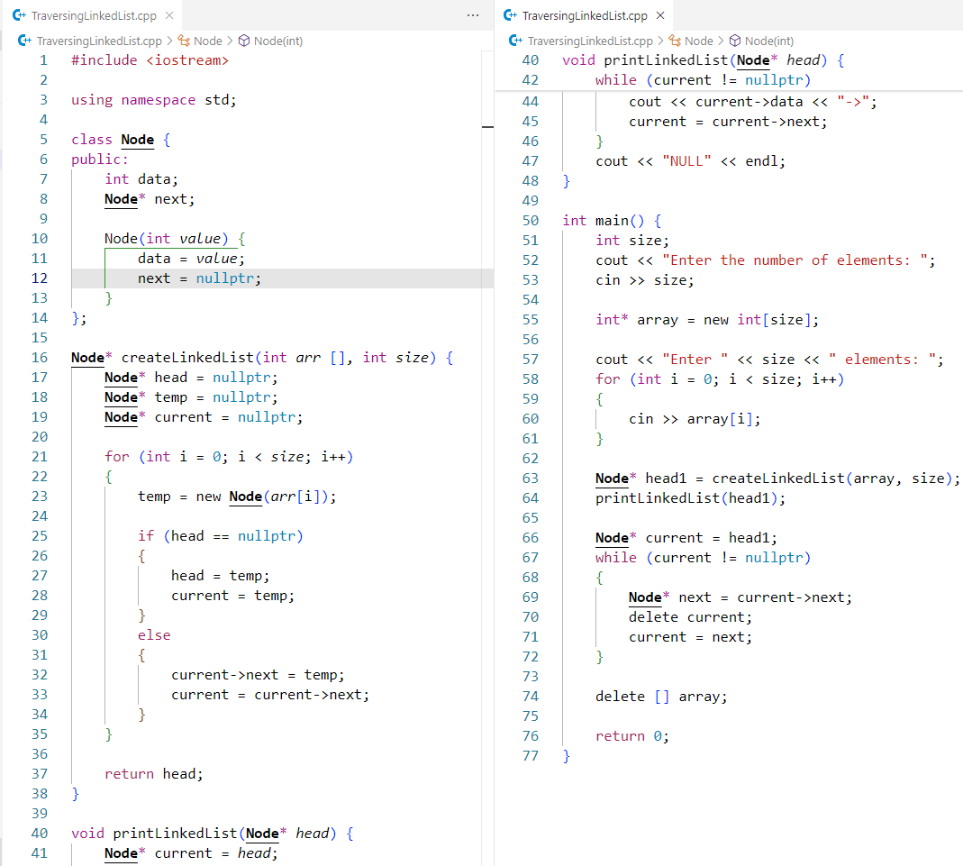Code:

Output:

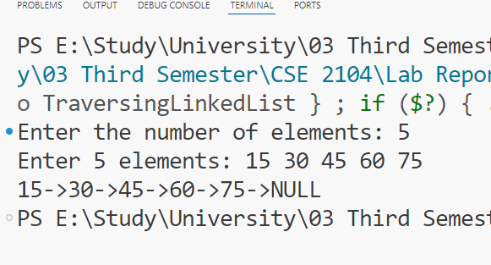

Problem 2: Write a C++ program to create and search for an element in a singly linked list.

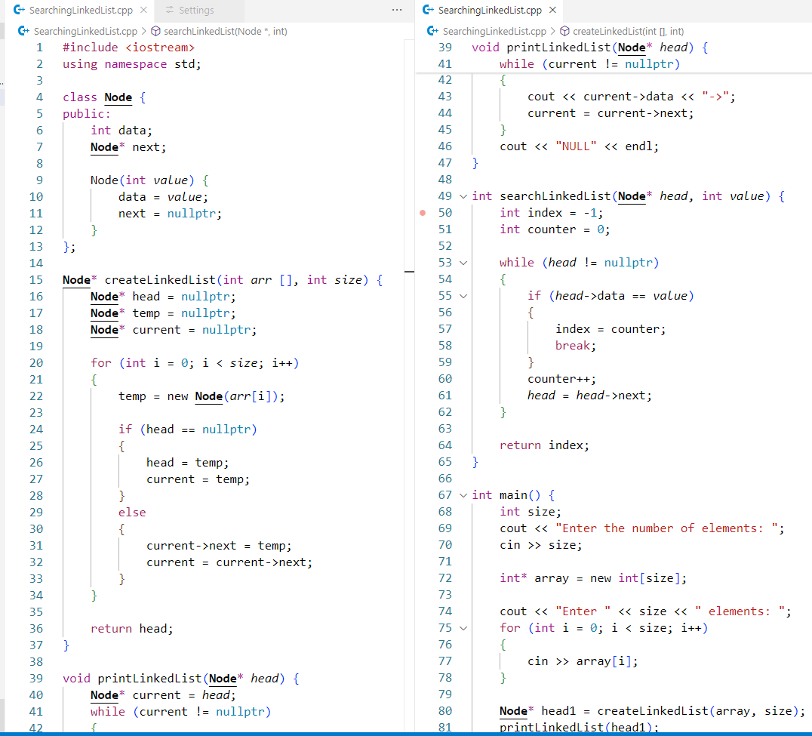Code:

Output:

